By using Session Manager Parameter Store creating our   
domain credentials in a parameter and get these in encryption and   
decryption formats.

1. Create parameter in development level.  
2.AWS Systems Manager → Parameter Store → /my-app/dev/db-url

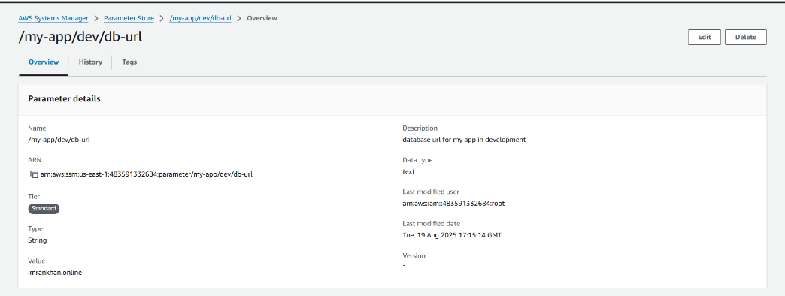

And create another parameter for app password

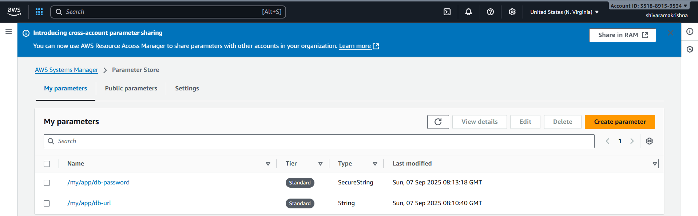

Open cloudshell cli or any cli and get parameters  
aws ssm get-parameters --names /my-app/dev/db-url /my-app/dev/db-password

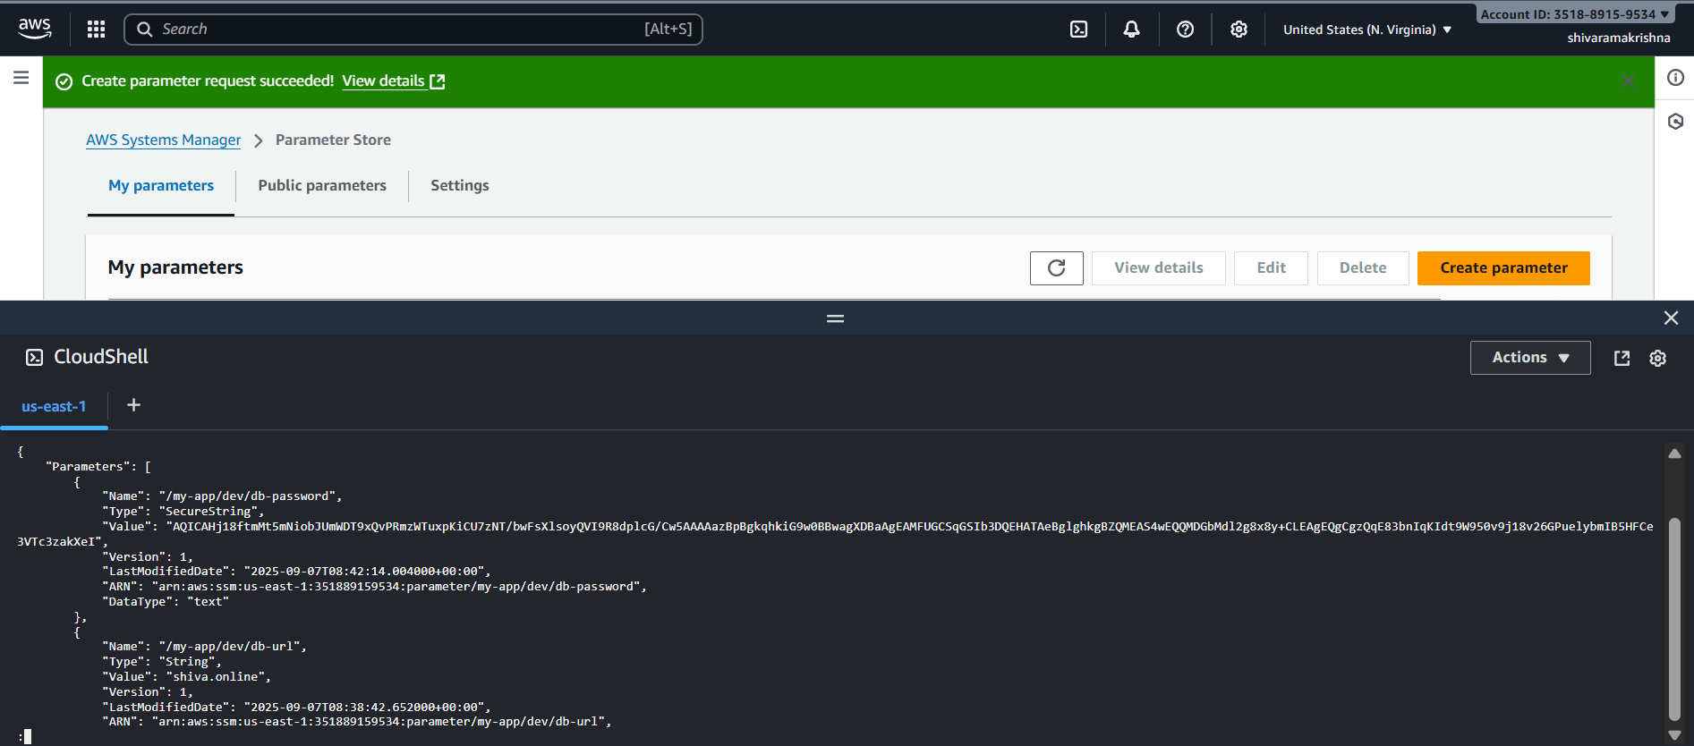

For string we get plain text but for secure string having password came in encrypted  
Now try to decrypt we can get both url and password in plain text

cmnd

aws ssm get-parameters --names /my-app/dev/db-url /my-app/dev/db-password --with-decryption

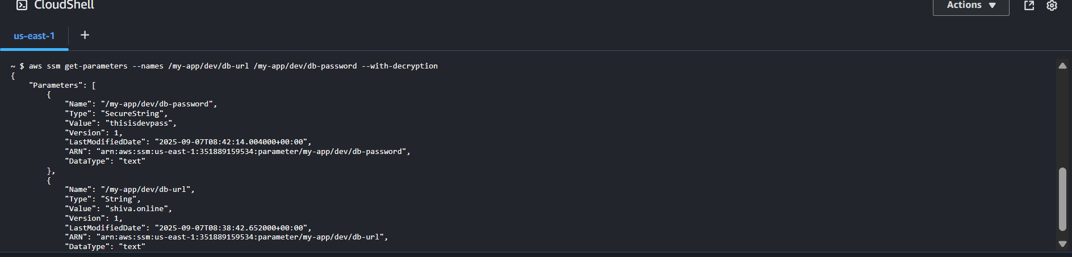

We can get the parameters by giving path also  
aws ssm get-parameters-by-path --path /my-app/dev

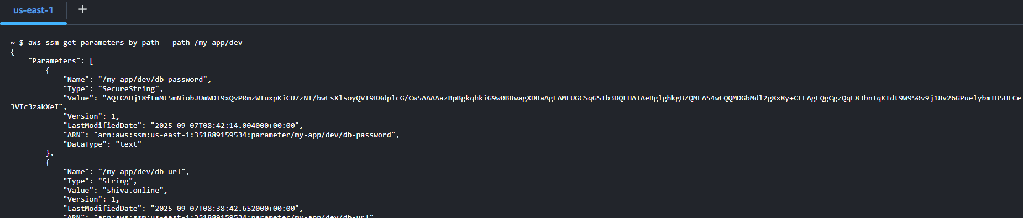

We can get all parameters using recursive  
aws ssm get-parameters-by-path --path /my-app/ --recursive

Now getting all parameters in plain text using recursive decryption.  
aws ssm get-parameters-by-path --path /my-app/ --recursive --with-decryption

